**Exercise 1:**

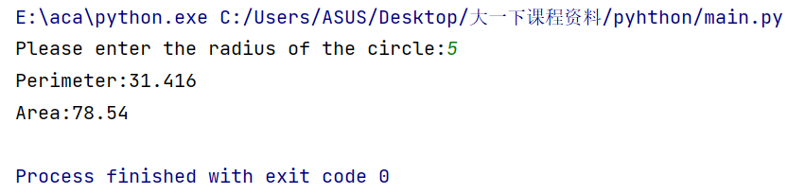

**Exercise 2:**

**Situation1:**

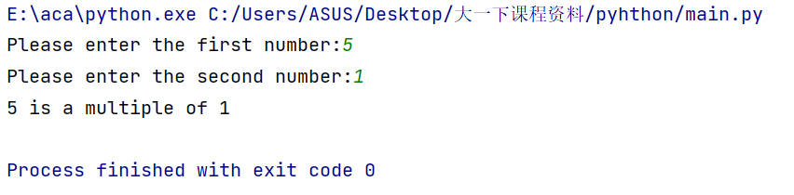

**Situation2:** 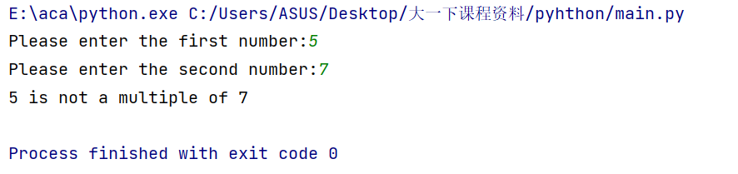

**Situation3:**

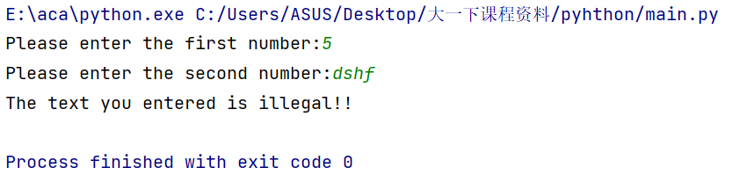

**Exercise 3:**

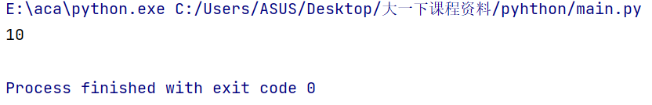

**Exercise 4:**

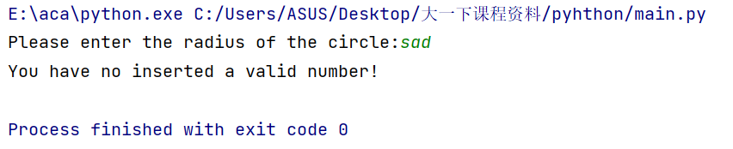

**Exercise 5-1:**

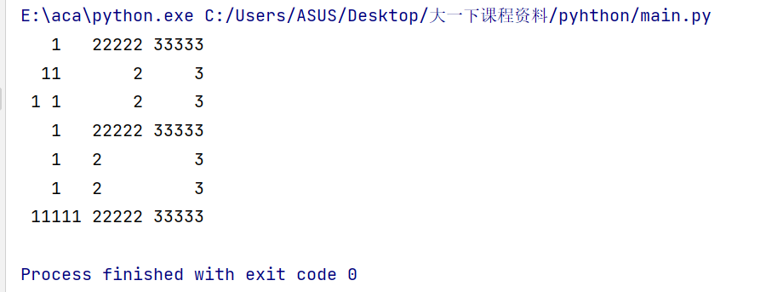

**Exercise 5-2:**

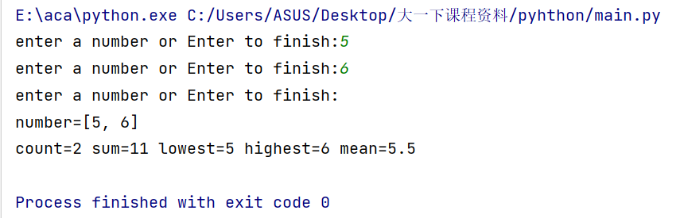

**Exercise 5-3:**

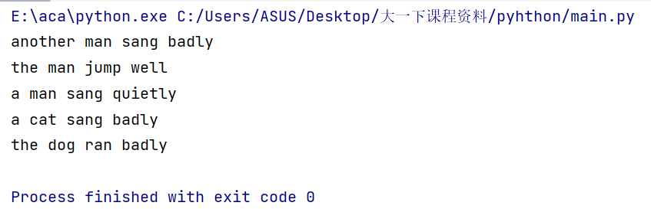

**Exercise 5-4**

**Situation 1:**

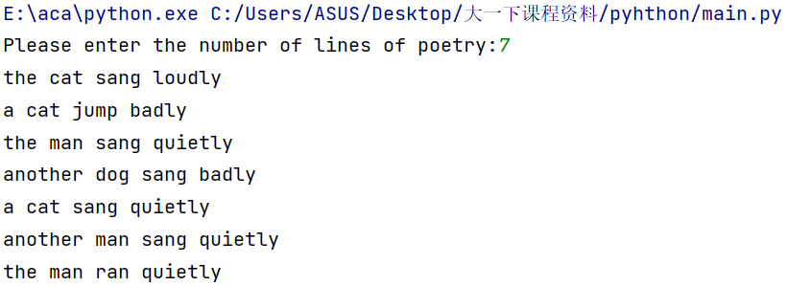

**Situation 2:**

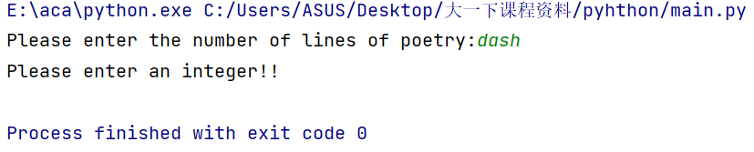

**Exercise 5-5:**

